Increment 2 Advanced Software Engineering Project

Swinney Genie

Services were written in visual basic 2013 in the service.svc file of the WCF application. Required Databases were added to and queries were written in the services to access the Databases. The services thus written are consumed from the client through HTML and Javascript. This can be shown below:

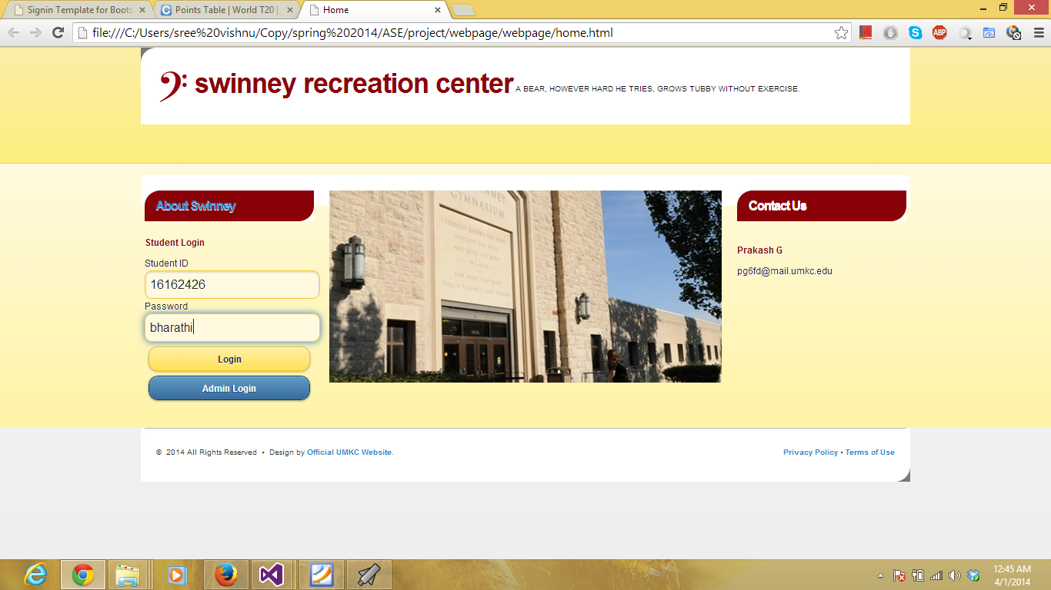

Student Logins in the account.

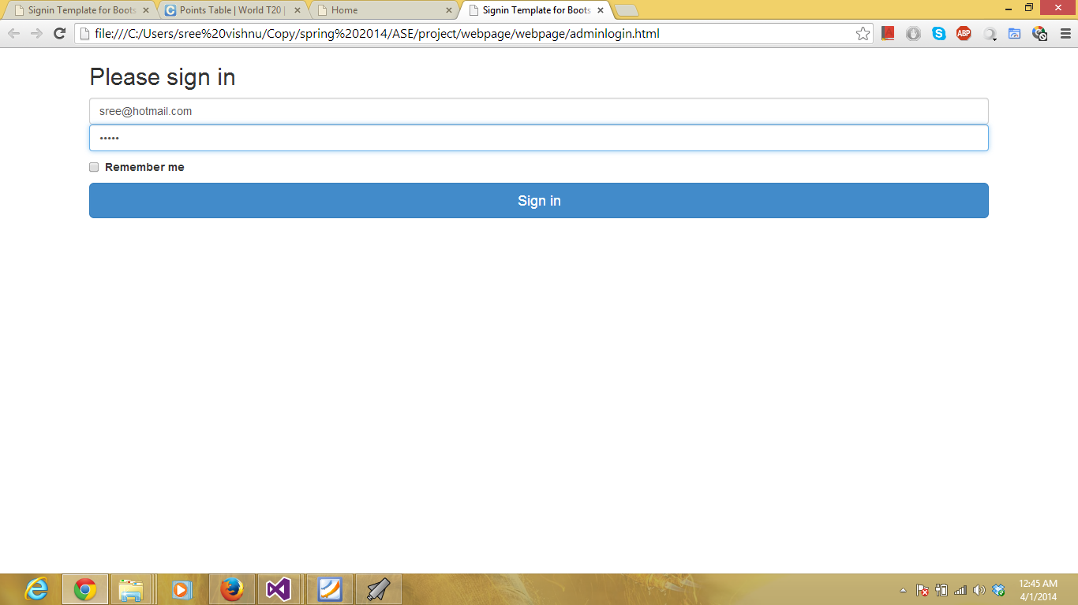

Admin Login is selected and username and password were entered. Admincheck service is consumed now.

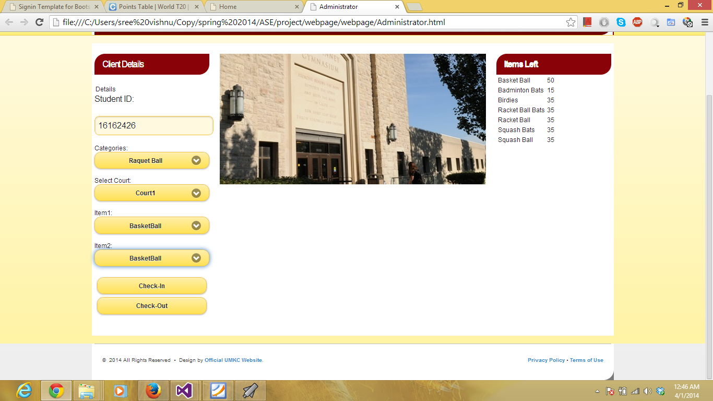

Now the required fields are selected and the data is entered in the fields required. Now the dataenter service is consumed.

All the data is stored in the database. From the database the data is retrieved and sent to the user client.

